**Phase 4**

**1. Validation Rules**

**Object:** Food Donation  
**Rule:** Quantity should be more than 0

* Setup → Object Manager → Food Donation → Validation Rules → New
* Formula:

Quantity__c <= 0

* Error Message: “Quantity must be greater than 0.”

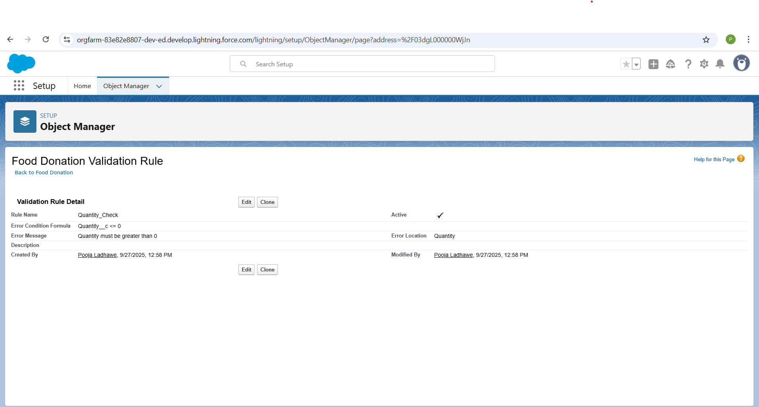

**2. Workflow Rules**

**Object:** Pickup Request  
**Rule:** When Pickup Request is created and Status = Pending, notify NGO.

* Setup → Workflow Rules → New → Object: Pickup Request
* Criteria: Status = 'Pending'
* Actions:
  + **Email Alert:** Notify NGO
  + **Task:** Assign volunteer to collect food

**3. Process Builder**

**Object:** Food Donation  
**Rule:** When donation is approved → update Pickup Request & notify donor

* Setup → Process Builder → New → Object: Food Donation
* Criteria: Status = 'Approved'
* Actions:
  + Update related Pickup Request → Status = “Ready”
  + Send Email Alert → Donor

**4. Approval Process**

**Object:** Food Donation

* Entry Criteria: Quantity > 0 AND Status = 'Submitted'
* Approver: NGO Manager
* Actions:
  + On submission → Notify approver
  + On approval → Change Status = Approved
  + On rejection → Notify donor

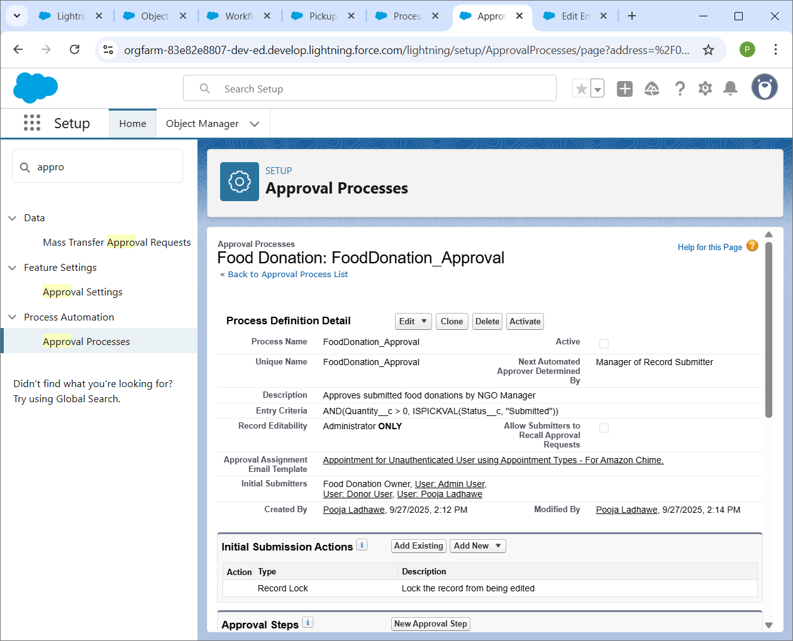

**5. Flow Builder**

**a) Screen Flow**

* Purpose: Volunteer enters pickup details
* Object: Pickup Request

**b) Record-Triggered Flow**

* Purpose: When Pickup Request is created → notify volunteer & update donor
* Trigger: Pickup Request created

**c) Scheduled Flow**

* Purpose: Daily report of pending donations → send to manager
* Object: Pickup Request
* Schedule: Every day at 9 AM

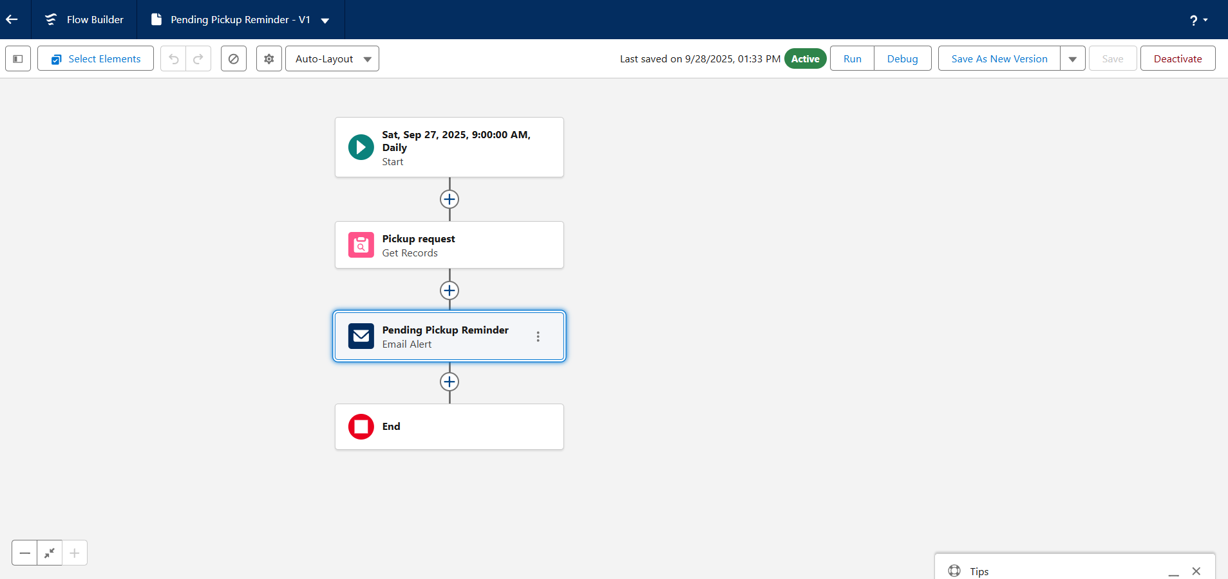

**d) Auto-Launched Flow**

* Purpose: After approval of Food Donation → update related NGO Profile

**6. Email Alerts**

* Object: Food Donation / Pickup Request
* Examples:
  + Notify NGO: New Pickup Request
  + Notify Donor: Donation Approved

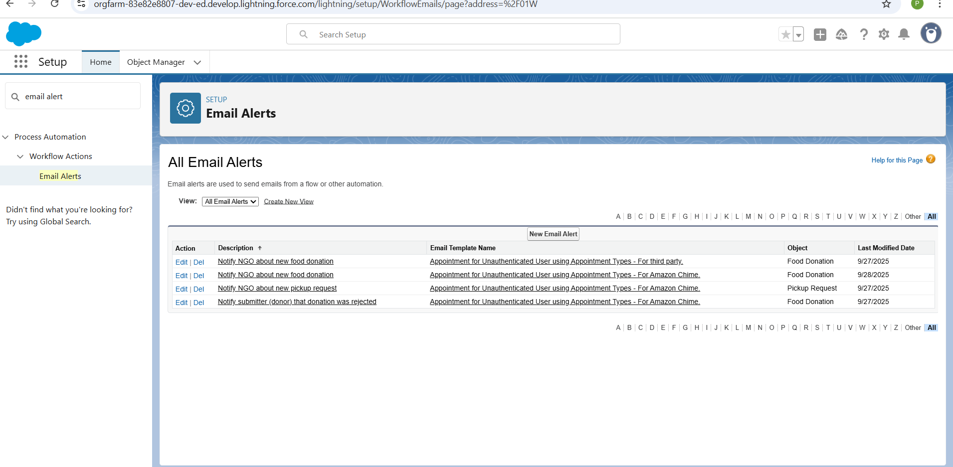

**7. Field Updates**

* Object: Pickup Request
* Example: Status = Pending → Completed after pickup

**8. Tasks**

* Object: Pickup Request
* Create task for volunteer → collect food within 24 hrs

**9. Custom Notifications**

* Object: Pickup Request / Food Donation
* Example: Notify donor inside Salesforce when NGO confirms pickup